May 1, 2024

Subject: Bid No. 4114.7, Classroom Furniture

This is Amendment Number 1

In accordance with the terms of the above-mentioned contract, this is authorization to extend this contract, through April 30, 2025. All terms and conditions remain the same.

Supplier(s):

American Design Associates, Inc.
Diversified Educational Systems, Inc.
Douron, Inc.

COMMENTS:
Revised contract summary attached.

REFER QUESTIONS TO: Saudy Espinal, Buyer II, 240-740-7537

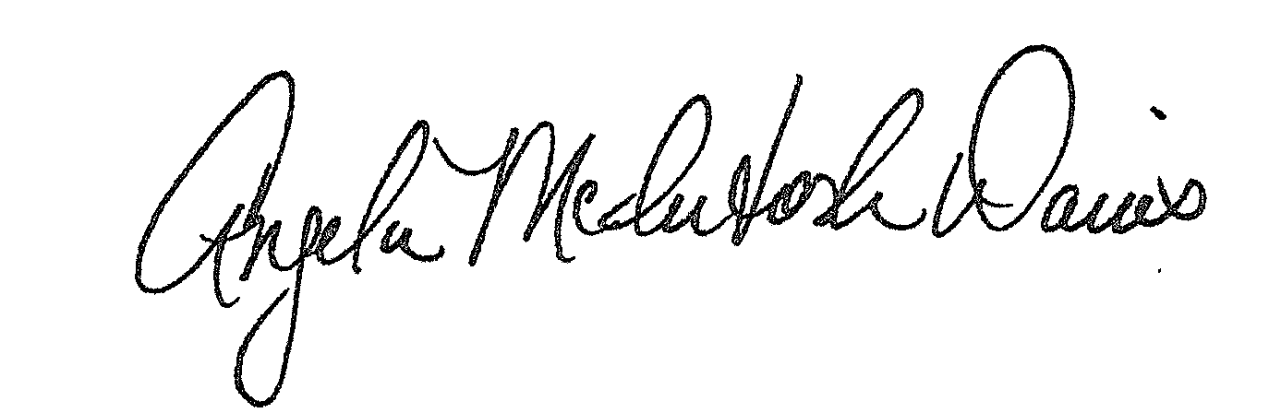

Approved:
Angela McIntosh-Davis, CPPB, Director, Division of Procurement

AMD: se

Distribution: Supplier(s); Bid File

